**Step 1: Setup Git Repository**

**Description:**  
Created a new folder git-ignore-lab and initialized it as a Git repository.

**Commands Used:**

git --version

cd /c/Users/Dell/GitDemo

cd /c/Users/Dell/GitDemo

git push origin master

**Screenshot(s):**

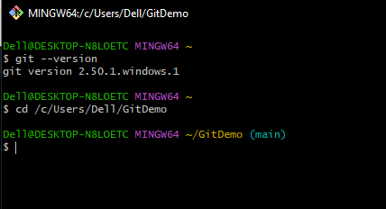

**Step 2: Create Sample Files**

**Description:**  
Created a .log file, a log folder with a file inside, and a normal text file.

**Commands Used:**

git branch GitNewBranch

git branch -a

git checkout GitNewBranch

echo "This is a new file in GitNewBranch" > branchfile.txt

**Screenshot(s):**  
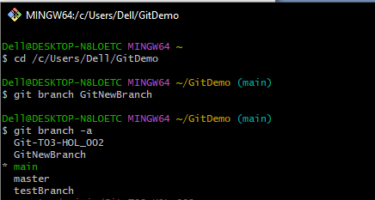

**Step 3: Create and Edit .gitignore File**

**Description:**  
Created .gitignore file and added rules to ignore .log files and the log folder.

**Commands Used:**

git add branchfile.txt

git commit -m "Added branchfile.txt in GitNewBranch"

git checkout master

git merge GitNewBranch

**Screenshot(s):**  
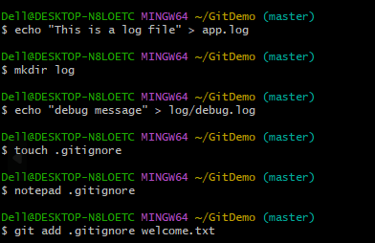

**Step 4: Verify Ignored Files**

Description:  
Checked git push origin master to verify .log files and log/ folder are ignored.

**Commands Used:**

git push origin master

git diff master..GitNewBranch

git log --oneline --graph --decorate --all

**Screenshot(s):**  
